|  |
| --- |
| **I2C Pattern Description** |
| **Version 1.0.0** |
| **Hau Sy Le** |
| **FED1/PER/TIMER** |

# Table of contents

Table of contents 2

1. Introduction 3

2. Startup package 4

2.1. Startup sequence for ARM processor 4

2.2. Individual ARM exception vectors table 4

2.3. Exception handlers 5

3. Software driver package 6

3.1. Heading 6

3.2. Heading 6

3.3. Heading 6

4. Heading 7

4.1. Heading 7

4.2. Heading 7

4.3. Heading 7

5. Reference documents 8

# Introduction

I2C has a functional verification package. This package contains 4 sub-packages as listed as below.

* **Startup package**

This package contains a startup sequence and an individual ARM exception vectors table written in ARM assembly for ARM processor and exceptions handler written in C.

* **Software driver package**

This package contains software driver for I2C and common modules such as PFC, CPG, GIC and DMAC.

* **Test patterns**

This package contains all I2C test patterns.

* **Scatter files**

This package contains scatter files necessary for the compilation step.

This document describes all the detail of this package.

# Startup package

## Startup sequence for ARM processor

The startup sequence for ARM processor is necessary to make the ARM processor to operate correctly. Each ARM processor version and architecture has its own startup sequence. The startup sequence for ARMv8-R 32-bits architecture is demonstrate as shown as below.

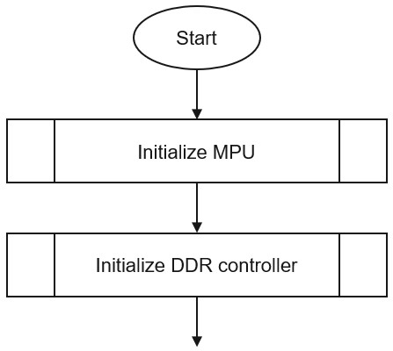

After the initialization of the DDR controller, the next sequence will be the C library initialization and the main function will be called after this sequence complete.

## Individual ARM exception vectors table

The ARM exception vectors table is copied to an individual source file and it will be placed in either internal SRAM memory or the DDR memory.

During execution, if there is any exception occurs, the ARM processor cannot access to the original exception vectors table which is located at the top of the BSC region because some of LSI pins are multiplex between I2C and LBSC, they will not available for LBSC to access to BSC region while I2C is in-use.

Therefore, an individual ARM exception vectors table located in a memory region outside of the BSC region is necessary for I2C patterns.

## Exception handlers

Exception handlers for ARM processor contains necessary action for each exception. Currently, only IRQ exception will be handled, the other exceptions will lead the processor to an infinity loop to prevent for incorrect result.

# Software driver package

This package contains software drivers for I2C and some common module such as PFC, CPG, DMAC and GIC. It has been written in C with object-oriented method to help developing the test patterns more easily and well organized.

This document only describes in detail for I2C software driver. I2C software driver supplies a set of functions to help to quickly configure an I2C channel to a desired operation mode, to send and receive data, get status and manage interrupts for the I2C.

## Master operation

## Slave operation

# Test patterns

This package contains a set of individual patterns written in C. Each pattern targeting to a specific test item in the CT check list.

All patterns use the software checking method that is comparing the test result with a golden result right in the code.

## Common check

### Register attributes check

This pattern checks the I2C’s registers attributes to see if they are consistency with the hardware manual. The expected results are:

* Registers address is correct
* Registers can be accessed
* Qualification (RW/RO/WO) is correct

The test procedure is shown as below.

Dump FAIL

result != golden?

Dump PASS

N

Y

REG 🡨 0xFFFFFFFF

result(1) 🡨 REG

REG 🡨 0x00000000

result 🡨 REG

Check register

Repeat for all registers

|  |  |
| --- | --- |
| **Note** | (1) **result** is an array containing read back data. It will be compared with the **golden** array element-by-element at the end of the test. |

### Module-stop check

This pattern checks the effect of a module-stop does to the I2C. The expected results are:

* I2C can be accessed normally before a module-stop.
* I2C cannot be accessed during a module-stop.
* Registers value are retained after a module-stop.
* I2C can be accessed normally after a module-stop.

The test procedure is shown as below.

Dump FAIL

result != golden?

Dump PASS

N

Y

Check register

REG 🡨 0xFFFFFFFF

Assert module-stop

Check register

Deassert module-stop

Result 🡨 REG

Check register

### Software reset check

This pattern checks the effect of a software reset does to the I2C. The expected results are:

* I2C can be accessed normally before a software reset.
* I2C cannot be accessed during a software reset.
* Registers value are reset after a software reset.
* I2C can be accessed normally after a software reset.

The test procedure is shown as below.

Dump FAIL

result != golden?

Dump PASS

N

Y

Check register

REG 🡨 0xFFFFFFFF

Assert software reset

Check register

Deassert software reset

Result 🡨 REG

Check register

### Pad connection check

### Interrupt check

## Master operation check

## Slave operation check

# Reference documents

[1] Author, *Name*, Year.